**BLYNK :-**It is an “Internet of things(IOT)” platform for connecting devices to the cloud, designing apps to remotely control and monitor hardware projects from IOS and Android device.

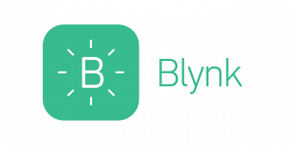

Major Components in BLYNK:-

=>BLYNK APP:-

It allows to create amazing interfaces for our projects using various widgets we provide and each project contain graphical widgets like virtual LEDs, Button, value Displays and can interact with more Devices.

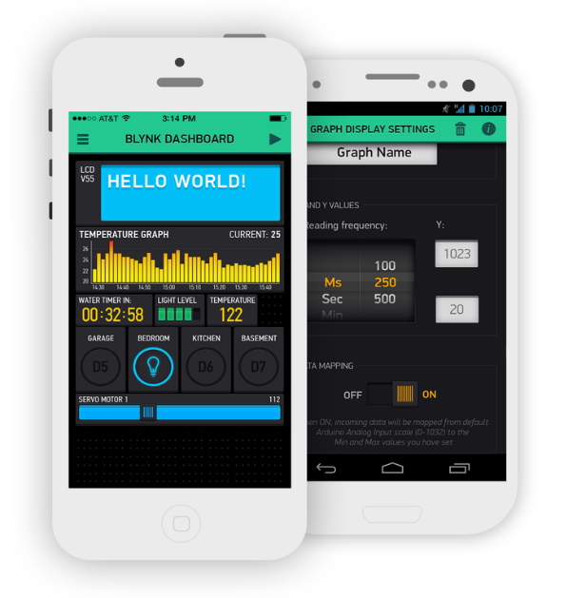

-It includes exclusively for Blink Mini camera.

-Blink Solar Panel Mount Overview.

-Alexa Skills and Features and Biometric Unlock.

-Photo Capture FAQ.

=>BLYNK SERVER:-It is an Open- Source Netty based java server, responsible for forwarding messages between Blynk mobile application and various microcontroller boards and SBCs (Arduino, Raspberry Pi.)

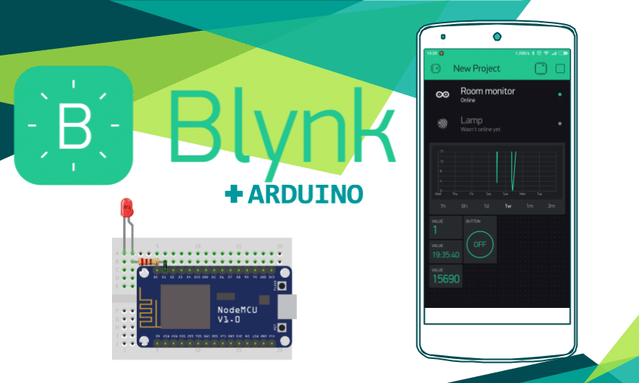

=>BLYNK LIBRARIES:-It is used for all the popular hardware problems-enable communication with the server and process all the incoming and outgoing commands. Blynk platforms is to make it super easy to develop the mobile phone applications.

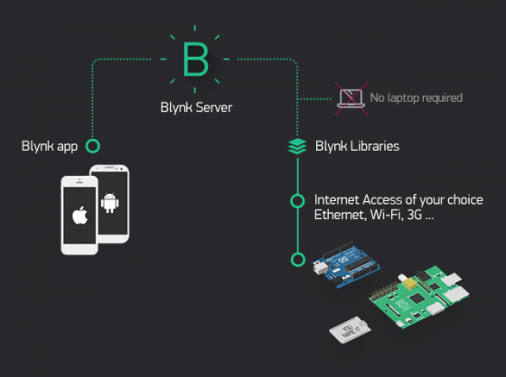-Blynk is free for personal use and prototyping.

-Blynk platform powers low-batch manufacturers of smart-home products.

-These companies build branded apps with no code and get the full back-end IOT infrastructure through 1 subscription.

-With Blynk anyone can connect their hardware to the cloud and build a no code IOS, Android, Web applications to analyse real-time and historical coming from devices, control them remotely from anywhere in the world.

-Blynk also offers a white-label solution which means you can add your company’s logo, app icon, choose the theme, colours, and publish the app to App store and Google Play under your company name.

-Blynk is a multi-tenant solution . you can configure how users get access to the data by setting roles and configuring permissions.

**APPLICATIONS:-**

-Bluetooth modules are supported on both IOS and Android.

-Smartphone and Hardware applications.

-Easily interact with microcontrollers or such as Raspberry Pi and NODEMCU via the internet.

-To create projects may contain widgets.

-For usage of Arduino Uno with an Ethernet Shield we use this library

“Blynk Simple Ethernet”.